**EXAM: CORONARY CT ANGIOGRAPHY WITH CALCIUM SCORE**

***CLINICAL HISTORY:*** suspicion Ischemic Heart Disease

***COMPARISION:*** None

***TECHNIQUE:*** Using a SOMATOM Drive scanner, a preliminary scout study was obtained, followed by coronary artery calcium protocol. Following administration of intravenous contrast, 0.5mm collimated images were obtained through the coronary arteries. Data were transferred off-line for 3D reconstructions including Curved MPR and multi-planar imaging.

***ACQUISITION:*** Prospective ECG triggering was used. Heart rate at the time of acquisition was approximately 64 bpm.

***MEDICATIONS:***

•        Betaloc: none

•        0.4mg sublingual nitroglycerine was administered immediately prior to scanning.

•        Contrast: IV injection of 75ml Xenetix.

***TECHNICAL QUALITY:*** excellent, with no artifacts.

***FINDINGS:***

Coronary Calcium (Agatston):

LM: 0

LAD: 0

LCX: 0

RCA: 0

The total calcium score is 0.

|  |  |
| --- | --- |
| **Left main:** | The left main coronary artery is a medium size vessel with diameter of 4.1 mm; bifurcates in LAD and LCX. |
|  | has no atherosclerotic lesion and no luminal stenosis. |
| **LAD:** | The left anterior descending artery is 3.5 mm in proximal diameter. It gives off 1 main patent diagonal branches. |
|  | has no atherosclerotic lesion and no luminal stenosis. |
| **LCX:** | The left circumflex artery is 3.3 mm in proximal diameter. It gives off a patent obtuse marginal branches (OM). |
|  | has no atherosclerotic lesion and no luminal stenosis |
| **RCA:** | The right coronary artery is 3.9 mm in proximal diameter. It gives off a patent right ventricular branch, a patent acute marginal branch (AM), a patent posterior descending artery (PDA) and a patent posterior left ventricular branch (PL). |
|  | has no atherosclerotic lesion and no luminal stenosis. |

**Cardiac function:** Left ventricular ejection fraction is good at 64%. No wall motion abnormality.

**Pericardium:** The pericardial contour is preserved with no effusion, thickening or calcification.

**Extra-cardiac findings:** There are no significant extra-cardiac findings in the available limited views of the lungs and mediastinum.

***IMPRESSION:***

|  |  |  |
| --- | --- | --- |
| 1. | The total calcium score is 0. | |
|  |  | |
| 2. | Coronary artery: | |
|  | LM: | has no atherosclerotic lesion and no luminal stenosis |
|  | LAD: | has no atherosclerotic lesion and no luminal stenosis |
|  | LCX: | has no atherosclerotic lesion and no luminal stenosis |
|  | RCA: | has no atherosclerotic lesion and no luminal stenosis |

Management recommendation: the limitations of CT scanning in evaluating severely calcified lesions, which can obscure the vascular lumen, we recommend further evaluation using coronary angiography. This invasive diagnostic procedure will provide more detailed and accurate information about the extent and severity of the lesions.

***KẾT LUẬN:***

|  |  |  |
| --- | --- | --- |
| 1. | Tổng điểm vôi hóa mạch vành bằng 0. | |
|  |  | |
| 2. | Động mạch vành: | |
|  | LM: | không có mảng xơ vữa, không hẹp lòng mạch. |
|  | LAD: | không có mảng xơ vữa, không hẹp lòng mạch. |
|  | LCX: | không có mảng xơ vữa, không hẹp lòng mạch. |
|  | RCA: | không có mảng xơ vữa, không hẹp lòng mạch |

Report Indicator/Mức độ của báo cáo: Normal/Bình Thường

**Khuyến cáo:** Những hạn chế của chụp CT trong việc đánh giá các tổn thương có vôi hóa nặng, có thể che khuất lòng mạch, chúng tôi đề nghị nếu có thể nên đánh giá thêm bằng chụp động mạch vành dưới DSA, đây là thủ thuật chẩn đoán xâm lấn sẽ cung cấp thông tin chi tiết hơn và chính xác hơn về mức độ nghiêm trọng của những tổn thương có vôi hóa.

There is a patent foramen ovale (PFO)/ Tồn tại lỗ bầu dục

"Patent foramen ovale (PFO) is visualized, characterized by a tunnel-like communication between left and atrium at the fossa ovalis location. The defect measures 4mm in diameter with a tunnel length of 8mm. No associated atrial septal aneurysm is noted."

"Tồn tại lỗ bầu dục (PFO) được quan sát thấy, đặc trưng bởi một đường thông dạng đường hầm giữa tâm nhĩ phải và tâm nhĩ trái tại vị trí hố bầu dục. Khiếm khuyết có đường kính 4mm với chiều dài đường hầm 8mm. Không ghi nhận phình vách liên nhĩ kèm theo."  
  
  
Giãn động mạch chủ lên./ Ascending aorta dilatation, D = >37mm.

**EXAM: CARDIAC CT SCAN REPORT: LEFT ATRIAL APPENDAGE (LAA) CLOSURE EVALUATION**

**CLINICAL HISTORY:** [Brief summary of relevant medical history, including atrial fibrillation diagnosis, anticoagulation use, and rationale for LAA closure consideration]

**TECHNIQUE:** Administration of intravenous contrast …cc, 0.5 mm collimated images were obtained. Delayed phase imaging was acquired 60 seconds post contrast injection to optimize visualization of the left atrial appendage (LAA) anatomy.

Data were transferred off-line for 3D reconstructions including Curved MPR and multi-planar imaging.

**ACQUISITION:** Retrospective ECG triggering was used. Heart rate at the time of acquisition was approximately [70 ] bpm.

**MEDICATIONS:** None

**INDICATION:** Evaluation for potential left atrial appendage (LAA) closure to reduce stroke risk in a patient with atrial fibrillation with high risk of bleeding.

**Reason for non-coronary visualization:** Technical limitations

**FINDINGS:**

**LAA Morphology:** The LAA demonstrates a [chicken wing / cauliflower / cactus / dumbbell / other] morphology.

A chicken wing morphology is considered favorable for LAA closure procedures due to its well-defined neck and appendage body.

**LAA Neck:**

Diameter: [5 mm] (This is considered within the acceptable range for most LAA closure devices. However, the specific size requirement may vary depending on the chosen device).

Depth: [5 mm] (Adequate depth allows for secure placement of the closure device).

**Relationship to Surrounding Structures:**

**Circumflex artery:** The distance between the LAA neck and the circumflex artery is [2 mm]. This adequate distance minimizes the risk of inadvertent injury to the artery during LAA closure.

**Pulmonary veins:**

Right superior pulmonary vein (RSPV): The distance between the LAA and the RSPV is [5 mm]. This spacing ensures safe placement of the closure device without compromising blood flow through the vein.

Right inferior pulmonary vein (RIPV): The distance between the LAA and the RIPV is [7 mm]. This adequate spacing is desirable.

Left superior pulmonary vein (LSPV): The distance between the LAA and the LSPV is [6 mm]. This spacing allows for safe LAA closure.

Left inferior pulmonary vein (LIPV): The distance between the LAA and the LIPV is [8 mm]. This spacing is considered adequate.

**LAA Thrombus:** No evidence of LAA thrombus was identified on this CT scan. The absence of thrombus is a positive finding, as it reduces the risk of stroke associated with LAA closure procedures.

**LAA Volume:** Due to technical limitations, this CT scan did not assess the LAA volume. However, the overall size of the LAA appears suitable for LAA closure devices based on the neck diameter and depth measurements.

**LAA Appendage Orifice (LAAO):** The size and shape of the LAAO, which is the opening of the LAA, could not be definitively evaluated with this CT scan. However, the chicken wing morphology typically suggests a favorable LAAO for closure procedures.

**LAA Diverticula:** No LAA diverticula were identified on this CT scan. The absence of diverticula simplifies the LAA closure procedure.

**IMPRESSION:**

This detailed CT scan analysis demonstrates potentially favorable anatomical features for LAA closure. The LAA morphology, neck size, and relationship to surrounding structures suggest compatibility with most LAA closure devices.

Additionally, the absence of LAA thrombus reduces the risk of stroke during and after the procedure.

However, limitations exist:

Coronary artery visualization: The coronary arteries were not visualized due to [technical limitations]. A separate evaluation, such as coronary angiography, may be required to assess for coronary artery disease.

LAA volume and LAAO: These details could not be definitively evaluated with this CT scan.

**Recommendations:**

Correlate these findings with clinical history, other imaging modalities (e.g., transthoracic echocardiography), and laboratory results for a comprehensive assessment.

Consultation with a cardiologist specializing in structural heart interventions is recommended to discuss the suitability of LAA closure based on all available data and determine the most appropriate treatment approach.

|  |
| --- |
| EXAM: CARDIAC CT SCAN REPORT: LEFT ATRIAL APPENDAGE (LAA) CLOSURE EVALUATION |
| **CLINICAL HISTORY:** [Brief summary of relevant medical history, including atrial fibrillation diagnosis, anticoagulation use, and rationale for LAA closure consideration]  **TECHNIQUE:** Administration of intravenous contrast …cc, 0.5 mm collimated images were obtained. Delayed phase imaging was acquired 60 seconds post contrast injection to optimize visualization of the left atrial appendage (LAA) anatomy.  Data were transferred off-line for 3D reconstructions including Curved MPR and multi-planar imaging.  **ACQUISITION:** Retrospective ECG triggering was used. Heart rate at the time of acquisition was approximately [70 ] bpm.  **MEDICATIONS:** None  **Indication:** Evaluation for potential left atrial appendage (LAA) closure to reduce stroke risk in a patient with atrial fibrillation with high risk of bleeding.  **Reason for non-coronary visualization:** Technical limitations |
| **Findings:**  **LAA Morphology:** The LAA demonstrates a [chicken wing / cauliflower / cactus / dumbbell / other] morphology.  A chicken wing morphology is considered favorable for LAA closure procedures due to its well-defined neck and appendage body.  **LAA Neck:**  Diameter: [5 mm] (This is considered within the acceptable range for most LAA closure devices. However, the specific size requirement may vary depending on the chosen device).  Depth: [5 mm] (Adequate depth allows for secure placement of the closure device).  **Relationship to Surrounding Structures:**  Circumflex artery: The distance between the LAA neck and the circumflex artery is [2 mm]. This adequate distance minimizes the risk of inadvertent injury to the artery during LAA closure.  Pulmonary veins:  Right superior pulmonary vein (RSPV): The distance between the LAA and the RSPV is [5 mm]. This spacing ensures safe placement of the closure device without compromising blood flow through the vein.  Right inferior pulmonary vein (RIPV): The distance between the LAA and the RIPV is [7 mm]. This adequate spacing is desirable.  Left superior pulmonary vein (LSPV): The distance between the LAA and the LSPV is [6 mm]. This spacing allows for safe LAA closure.  Left inferior pulmonary vein (LIPV): The distance between the LAA and the LIPV is [8 mm]. This spacing is considered adequate.  **LAA Thrombus:** No evidence of LAA thrombus was identified on this CT scan. The absence of thrombus is a positive finding, as it reduces the risk of stroke associated with LAA closure procedures.  **LAA Volume:** Due to technical limitations, this CT scan did not assess the LAA volume. However, the overall size of the LAA appears suitable for LAA closure devices based on the neck diameter and depth measurements.  **LAA Appendage Orifice (LAAO):** The size and shape of the LAAO, which is the opening of the LAA, could not be definitively evaluated with this CT scan. However, the chicken wing morphology typically suggests a favorable LAAO for closure procedures.  **LAA Diverticula:** No LAA diverticula were identified on this CT scan. The absence of diverticula simplifies the LAA closure procedure.  **Impression:**  This detailed CT scan analysis demonstrates potentially favorable anatomical features for LAA closure. The LAA morphology, neck size, and relationship to surrounding structures suggest compatibility with most LAA closure devices.  Additionally, the absence of LAA thrombus reduces the risk of stroke during and after the procedure.  However, limitations exist:  **Coronary artery visualization:** The coronary arteries were not visualized due to [technical limitations]. A separate evaluation, such as coronary angiography, may be required to assess for coronary artery disease.  **LAA volume and LAAO:** These details could not be definitively evaluated with this CT scan.  **Recommendations:**  **Correlate these findings with clinical history, other imaging modalities (e.g., transthoracic echocardiography), and laboratory results for a comprehensive assessment.**  **Consultation with a cardiologist specializing in structural heart interventions is recommended to discuss the suitability of LAA closure based on all available data and determine the most appropriate treatment approach.** |

|  |
| --- |
| **Examples** |
|  |
| The distal LAD has a atherosclerotic lesion with features of positive remodeling, None-calcified, high-attenuation (>30 HU), homogenous, that cause narrowing 50-70% of the lumen. |
| Tại đoạn gần LAD có một mảng xơ vữa với đặc điểm sau tái cấu trúc dương, không vôi hóa, cản quang kém, đồng nhất, gây hẹp lòng mạch 50-70%. |
| The distal LCx has a atherosclerotic lesion with features of positive remodeling, None-calcified, high-attenuation (>30 HU), homogenous, that cause narrowing 50-70% of the lumen. |
| Tại đoạn gần LCx có một mảng xơ vữa với đặc điểm sau tái cấu trúc dương, không vôi hóa, cản quang kém, đồng nhất, gây hẹp lòng mạch 50-70%. |
| The distal RCA has a atherosclerotic lesion with features of positive remodeling, None-calcified, high-attenuation (>30 HU), homogenous, that cause narrowing 50-70% of the lumen. |
| Tại đoạn gần RCA có một màng xơ vữa với đặc điểm sau tái cấu trúc dương, không vôi hóa, cản quang mất độ cao (>30 HU), đồng nhất, gây che lấp lòng mạch 50-70%. |
|  |
|  |
|  |
|  |
|  |
|  |
| There is a patent foramen ovale (PFO)/ Tồn tại lỗ bầu dục |
| Left ventricular concentric hypertrophy. |

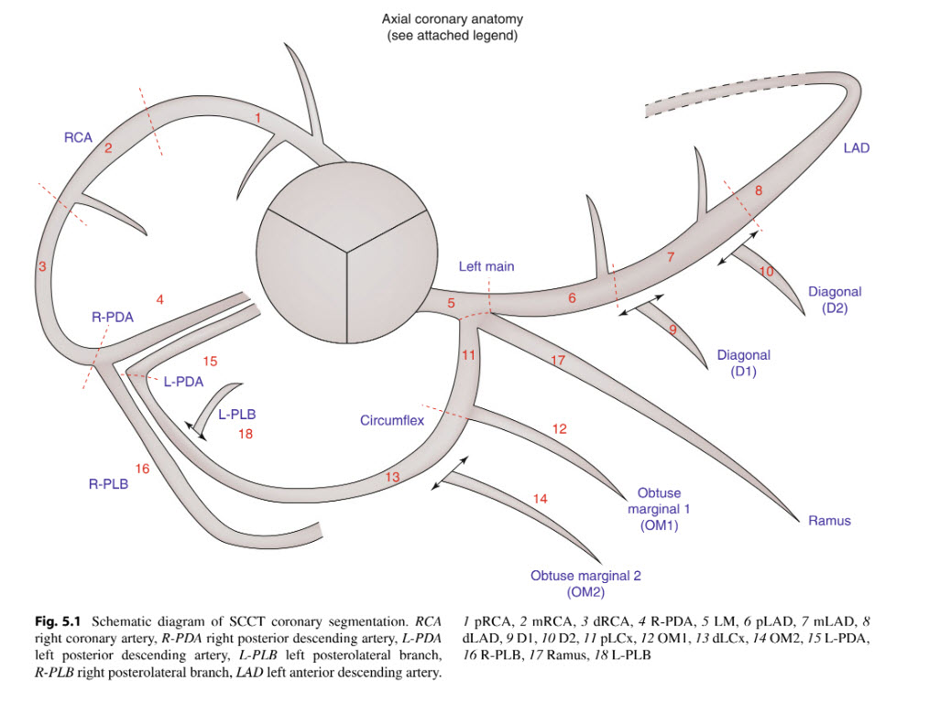

|  |  |  |  |  |
| --- | --- | --- | --- | --- |
| positive remodeling |  |  |  |  |
|  | spotty  (calcified lesions >3 mm) | calcified |  |  |
|  | Large  (calcified lesions <3 mm) | calcified |  |  |
|  |  | partially |  |  |
|  |  | None-calcified | napkin-ring sign |  |
|  |  |  | low-attenuation  (<30 HU) | homogenous |
|  |  |  | high-attenuation | heterogeneous |
| Plaque imaging with CT-a comprehensive review on coronary CT angiography  based risk assessment. | Semantic Scholar | | | | | |
|  | | | | | |

Rule 2: A segment of stenosis must be seen in at least two phases (e.g. percentages or millisecond) that are reconstructed.

If the heart rate is during the scan acquisition is <70bpm we find that a 75–80% reconstruction in diastole is usually all that is necessary, while if the heart rate is >70 then we find a reconstruction phase in late systole, e.g. 40– 45% is usually best.

Rule 3: A segment of stenosis is usually associated with plaque, which can be visualized at the segment of stenosis.

contrast opacification of the artery of 250– 350 HU

lipid and fibrous plaques

Soft or lipid plaque tends to be associated with a lower density of approximately 40–50 HU (Hounsfield units) while fibrous plaque tends to be associated with a density of about 90–100 HU.

|  |  |  |  |  |  |
| --- | --- | --- | --- | --- | --- |
| plaques |  |  |  |  |  |
|  | lipid | 40–50 |  |  |  |
|  | Fibrous | 90–100 |  |  |  |
|  | Calcified |  | 1500/350 |  |  |
|  | heart tissue |  | 1000/200 |  |  |

Rule 4: A segment of stenosis should be assessed in at least two orthogonal views to determine if there is a significant stenosis and compare ‘‘lumen to lumen’’, the diameter of contrast filled normal lumen with contrast filled lumen at level of stenosis, not ‘‘wall to wall’’ by looking at the outer wall of the artery.

As the atherosclerotic process develops, there is compensatory expansion in the vessel wall and increase in the vessel area and the vessel size enlarges, preserving the size of the lumen, although there is plaque present [21]. This is called positive remodeling. When the plaque size increases to about 40–45% of the vessel area then the lumen starts to narrow as vessel expansion is overcome. This is why conventional angiography consistently underestimates plaque burden.

Rule 5: Look for the ‘‘dark lumen’’ sign and use MPRs and CPRs to help you.

Rule 6: Review the images at different sets of window width and levels, especially if the contrast enhancement of the artery is not optimal or in the presence of calcified plaques.

the preset image window WW/WL is 1000/200 while the coronary arteries window WW/WL is preset at 500/230.

For calcified plaques we prefer a WW/WL of 1500/350.

When the vessel enhancement is poor, which can occur when the patient is very large or there is suboptimal venous access to allow high injection flow rate, we prefer a WW/WL in between and recommend 650–700/250.

When contrast density in the lumen of the coronary arteries is relatively

poor, a non-calcified plaque can be easily missed whentheWWistoowide.AWLof250isalso more suitable. Conversely, when there is dense enhancement of the lumen WW/WL of 1000/200 is more useful

When contrast density in the lumen of the coronary arteries is relatively poor, a non-calcified plaque can be easily missed whentheWWistoowide. AWL of 250 is also more suitable. Conversely, when there is dense enhancement of the lumen WW/WL of 1000/200 is more useful

The WW/WL should also both be set higher in the presence of calcified plaques. For calcified plaques we prefer a WW/WL of 1500/350.